**Welcome to the WCSD Languages other than English Program**  
  
This course is offered through WCSD and offers an immersive language learning experience on a daily basis for all students. Our World Language programs offer honor societies at the High School Level for all of our languages as well as opportunities for cultural and collaborative learning at the secondary levels. Through our language program, our students have the opportunity to achieve their Advanced Regents Diploma, the NYS Seal of Biliteracy and take Advanced Placement courses. Our students are guided by talented teachers with years of experience teaching in the district as well as at local colleges and universities. We align our work to the NYSED Standards of LOTE and the ACTFL World Readiness Standards for Learning Languages to provide opportunities for students to pursue their passion through language, culture and rigor.   
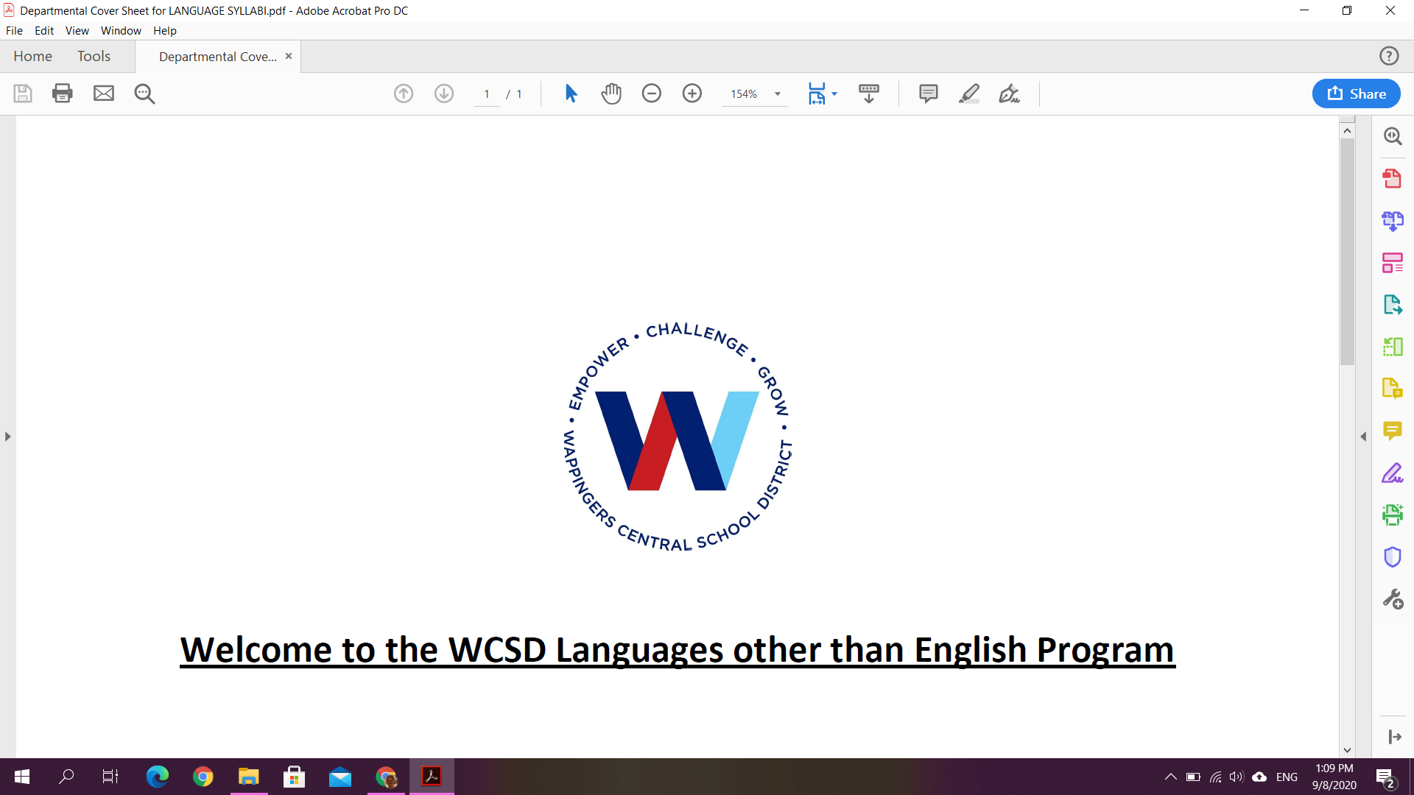

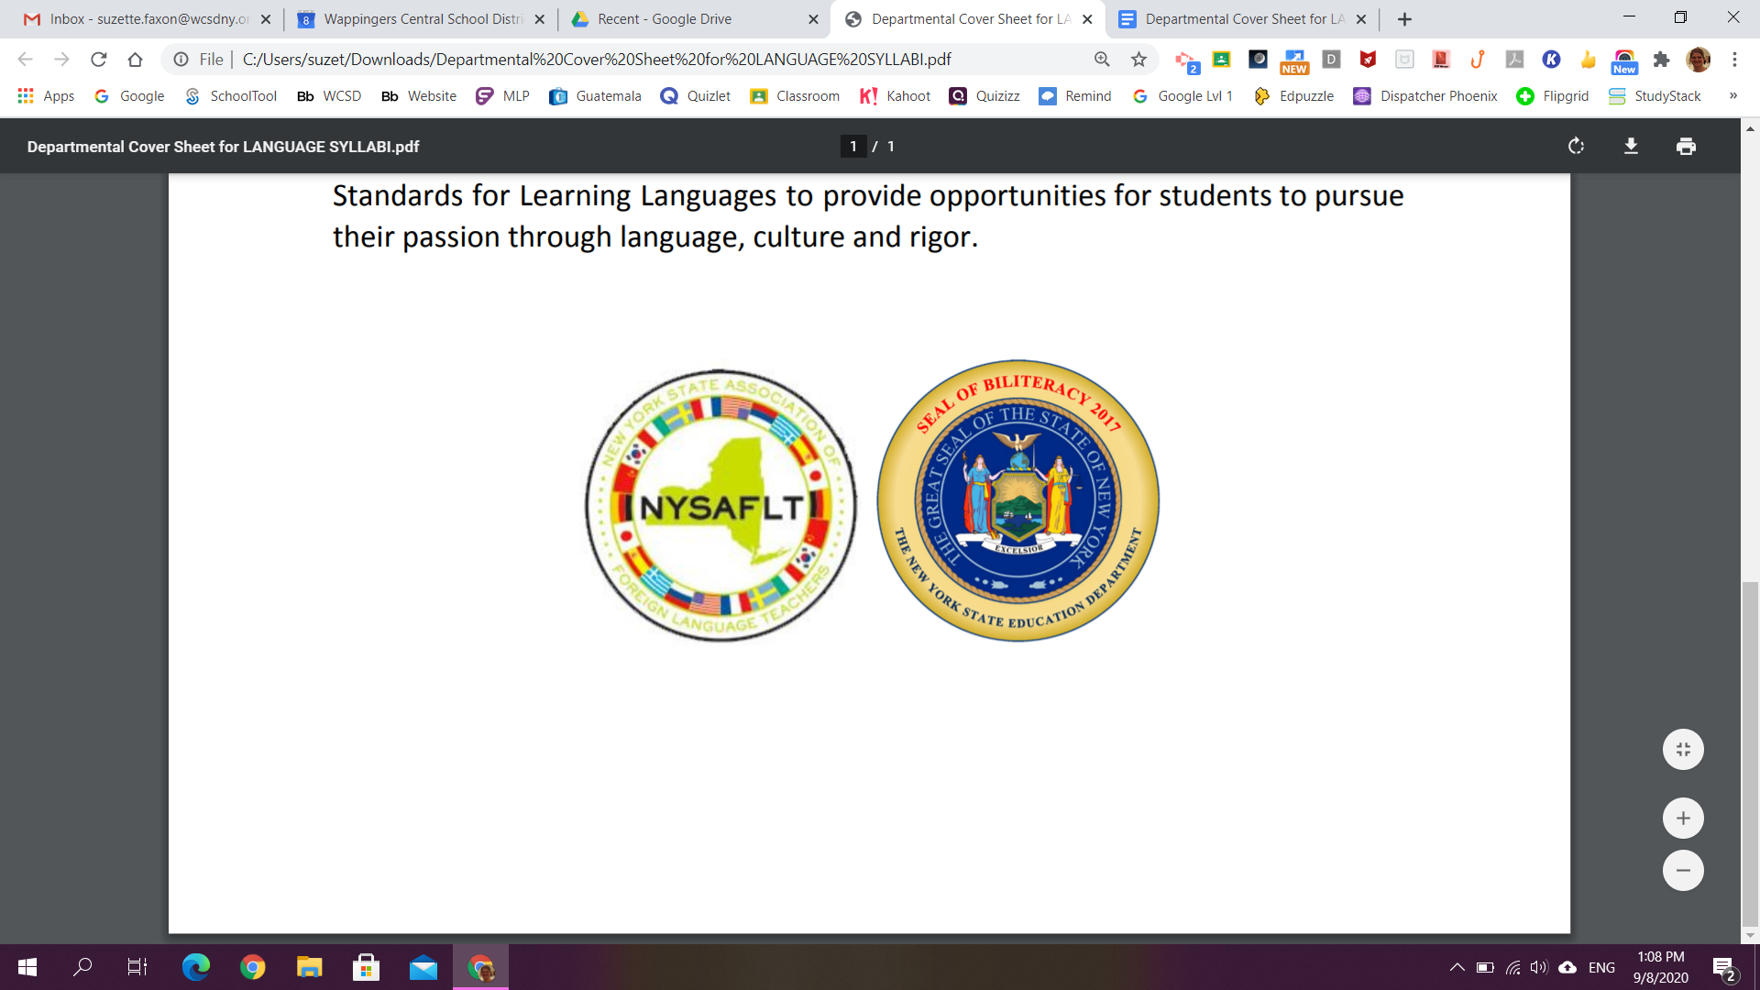

**La clase de español con Señora Faxon**

2022-2023

Sra. Suzette Faxon

Email: [suzette.faxon@wcsdny.org](mailto:suzette.faxon@wcsdny.org) -> This is the best way to contact me

Course: L516 (Spanish I) or L515 (Spanish 7)

Room 112  
Website: Click ‘Faxon, Suzette’ under the Van Wyck ‘Teachers’ tab

**Course Description:**

Learning a new language can be a very exciting and enjoyable experience. I encourage you to participate in and enjoy the activities planned for this academic school year.

Spanish I is spread over a two-year period in grades 7 & 8. The curriculum is centered on themes that are consistent with real life situations. At the end of 8th grade, students will receive one high school credit upon successful completion of the course and any pertinent assessment(s). Details will be provided regarding any assessments as they become available.

**The following 3 themes will guide the course of instruction this year:**

1. Identity & Social Relationships

2. Contemporary Life

3. Science, Technology & the Arts

*As per WCSD policy the use of cell phones are* ***prohibited*** *in the classroom.*

Please make every effort to use our daily class time to speak as much Spanish as possible -- the more you practice the easier it gets!

**\*It is the responsibility of *the student* to seek out and make up any missed assignments in a timely manner!\***

**Classroom Policies, Rules & Expectations:**

* Be respectful -- of me, of each other, of our classroom resources, and our time together
* Be responsible -- always do your best, complete all assignments in a timely manner, work daily to improve your Spanish skills, and ask for help if you need it
* Be safe -- follow all directions provided by me, the WCSD Code of Conduct, the student handbook, and the district’s guidelines for learning and class participation.
* I will provide you with the link to an online dictionary you can use when necessary. I’d rather you try your best and make mistakes than submit work that is not your own!
* This is a class where your participation will enable you to better learn how to read, write, speak, and understand Spanish. You will be expected to verbally participate in class.
* Eating is not allowed in class.

**Grading Policy:**

* You will be graded according to the following:
  + Practice Work → this may include, but is not limited to: classwork, listening, reading, writing, etc. → 20%
  + Speaking / Class Participation -> this may include, but is not limited to: formal speaking tasks, dialogues, etc. → 10%
  + Quizzes/ Projects/Journals → 30%
  + Tests → 40%
* You will be asked to complete assignments in Google classroom. It is your responsibility to refer to it each school day and to bring your chromebook to class. There will be times that you will complete work on paper instead of on your chromebook, but please be prepared for both.
* Work is to be completed in a timely manner. Points will be deducted for work submitted late.
* Students are expected to review their notes for 10-15 minutes each school day. All notes will be posted online in Google classroom.
* Please contact me if you need assistance completing work. **Extra help is by appointment only** since I will also have other obligations during my prep periods as well.

**Class Supplies**

**Items you will need to bring to class:**

* your school issued chromebook, charged
* charging cable for your chromebook
* earbuds / headphones
* a section divider labeled “Spanish” in a shared binder
* one pack of pens and/or pencils (#2) - can use mechanical pencils if you wish
* a pencil sharpener (if you aren’t using mechanical pencils)
* loose leaf paper
* one box of tissues

**\*NO folders!\***

**Items you will need to keep at home:**

* a pack of crayons/markers/colored pencils (just one & whichever you prefer; to be keep at home)
* construction paper or blank computer paper (for projects)

**I look forward to working with you this school year! Please feel free to email me to answer any questions that you may have.**

**Parents/Guardians: please retain a copy of this document for your records for reference throughout the academic year.**

- - - - - - - - - - - - - - - - - - - **Tear off this sheet & return it** - - - - - - - - - - - - - - - - - -

I have read and understand the syllabus for Sra. Faxon’s Spanish I class. I also understand that by signing and returning this form I agree to abide by its contents. **This sign off sheet is due by Wednesday, September 14th, 2022. *Please Print Legibly!\***

_______________ ____________________________

(Class Period) (Date)

_______________________________________________________________________  
(Student’s Name Printed)

_______________________________________________________________________

(Student’s Signature)

_______________________________________________________________________

(Print Parent/Guardian’s Name)

_______________________________________________________________________

(Parent/Guardian’s Signature)